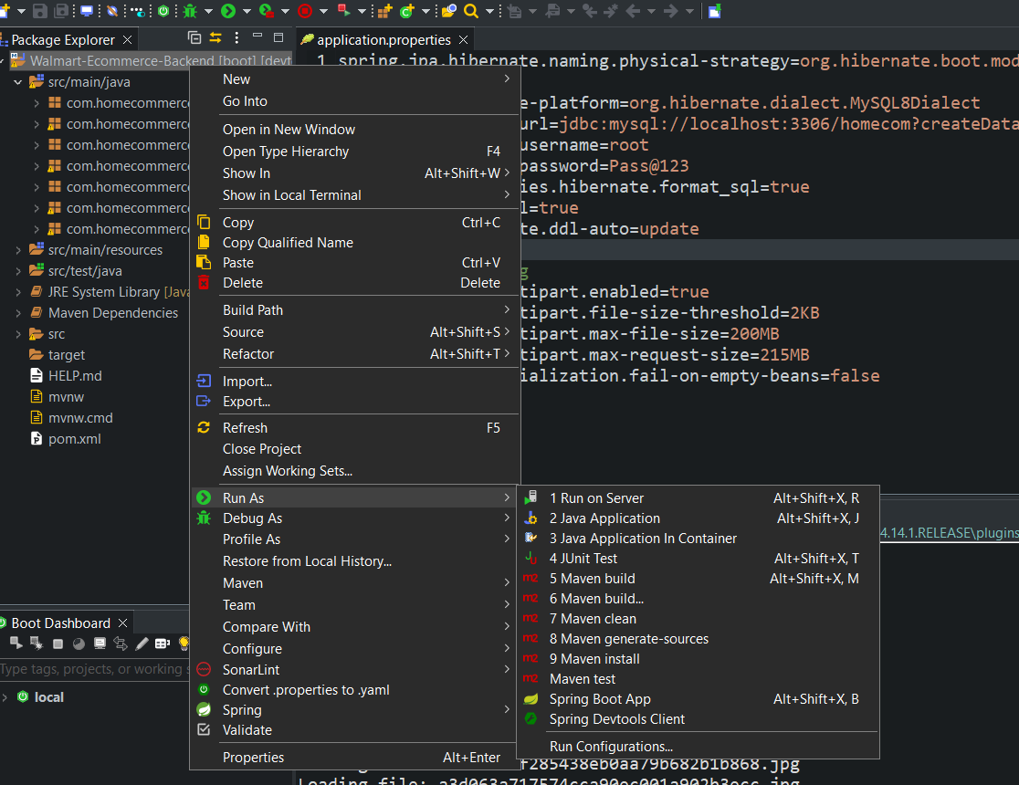

Run The backend Part First as Spring BOOT app

For the Frontend Part open the located folder with vs code then type in command terminal as ng serve

For admin part use locahost:4200\admin

